Final Project
Design and Document a Hybrid/Multi-Cloud Architecture
Global Retail Enterprise — Cloud Architect Submission

1. Architecture Design and Pattern Selection (5 Points)
The proposed architecture adopts an Active-Passive Disaster Recovery with Burst-to-Cloud hybrid multicloud pattern. The on-premises data center continues to serve as the compliance anchor for all regulated workloads — order processing, payment systems, inventory management, and financial records — preserving PCI-DSS and SOX compliance without re-engineering sensitive transaction flows. Amazon Web Services (AWS) functions as the primary cloud, hosting a warm standby environment in us-east-1 that mirrors on-premises transactional services via asynchronous database replication.
Microsoft Azure provides a dedicated analytics and machine learning platform, offloading compute-intensive personalization and business intelligence workloads that the on-premises environment cannot scale elastically. The active-passive pattern was selected over active-active because it delivers significant cost efficiency while still achieving the defined RTO of under four hours and RPO of under fifteen minutes.
The key trade-off accepted is a brief recovery window rather than zero-downtime failover. This design improves availability by eliminating the single data center dependency, achieves horizontal scalability through containerized workloads on Kubernetes in the cloud, and strengthens resilience by automating failover through CloudWatch alarms and Route 53 DNS switching — replacing the previously manual and undocumented recovery procedures.

2. Routing and Failover Strategy (4 Points)
Global user traffic — from both web and mobile clients — is ingested through AWS Global Accelerator, which uses Anycast routing to direct requests to the nearest healthy AWS edge endpoint. CloudFront CDN PoPs (Points of Presence) distributed across the United States and Europe serve static and cacheable content, minimizing latency for end users during peak demand. Dynamic application traffic is forwarded to an Application Load Balancer in us-east-1, which distributes load across EKS-hosted microservices spanning two Availability Zones.
Amazon Route 53 provides DNS-based failover with active health checks executed every thirty seconds against the on-premises primary environment. Should health checks detect a primary site failure, Route 53 automatically updates DNS records to redirect traffic to the AWS warm standby environment, initiating the failover with no manual intervention required.
Azure Front Door serves European analytics traffic to the Azure West Europe region, enforcing EU data residency. This automated routing and failover design directly supports the recovery targets: the sub-fifteen-minute RPO is met through continuous asynchronous database replication, and the sub-four-hour RTO is met through pre-provisioned warm standby infrastructure that requires only DNS propagation and service validation to activate.

3. Data Placement and Replication Strategy (4 Points)
Data placement follows a sovereignty-first model. All primary transactional data — customer PII, order records, and financial transactions — resides exclusively on-premises within the HSM-protected, PCI-DSS-compliant database cluster.
Asynchronous replication continuously streams changed data from the on-premises primary to an Amazon RDS Aurora warm standby replica in AWS us-east-1, maintaining an RPO of under fifteen minutes. This replication uses AWS Database Migration Service (DMS) over a dedicated Direct Connect private link, ensuring data in transit never traverses the public internet. For European customers, transactional replicas and analytics data are maintained within AWS eu-west-1 and Azure West Europe respectively, satisfying GDPR data residency requirements.
Analytics workloads ingest anonymized and aggregated operational data into Azure Data Lake Gen2 via asynchronous ADF pipelines, decoupling analytics compute from production transactional systems. Nightly encrypted backups are written to AWS S3 with cross-region replication to both us-east-1 and eu-west-1, and mirrored to Azure Blob Storage for geo-redundancy. Backup integrity is validated monthly through automated restore testing, replacing the previously undocumented and infrequently tested manual backup process.

4. Architecture Diagram (4 Points)
The diagram below presents the complete future-state hybrid multicloud architecture. It includes all required elements: on-premises transactional systems, AWS and Azure cloud environments with multiple regions and Availability Zones, global routing components, data replication paths, failover directions, and a legend.

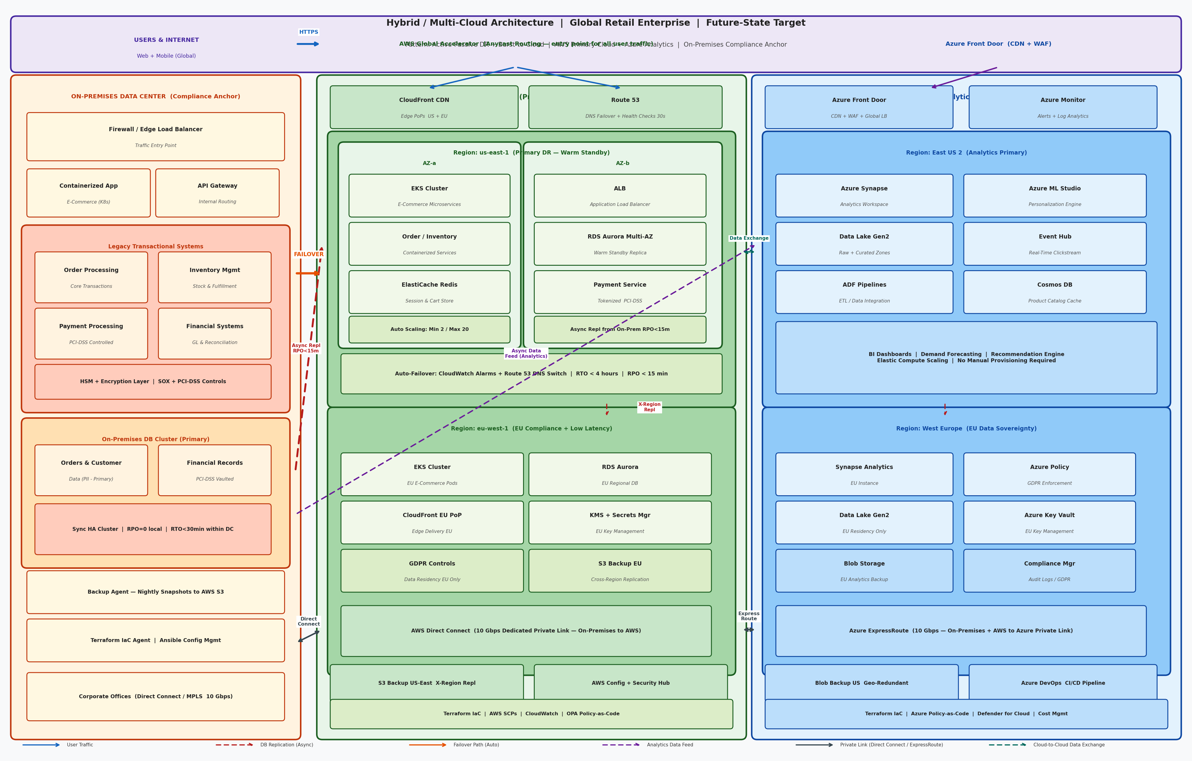
Figure 1: Hybrid / Multi-Cloud Future-State Architecture — Global Retail Enterprise

5. Justification and Documentation Clarity (3 Points)
The proposed architecture directly resolves each of the five critical weaknesses identified in the current single-region design.
The single data center dependency is eliminated by distributing workloads across on-premises infrastructure, AWS, and Azure, removing any single point of failure.
Scalability limitations are addressed by containerizing e-commerce workloads on Kubernetes with Auto Scaling Groups in AWS, enabling elastic capacity expansion during seasonal peaks without manual hardware provisioning cycles.
Insufficient disaster recovery is replaced by automated failover orchestrated through Route 53 health checks and CloudWatch alarms, with asynchronous replication guaranteeing RPO under fifteen minutes and warm standby infrastructure guaranteeing RTO under four hours — meeting leadership's explicit targets.
Platform lock-in is mitigated through containerized, portable workloads deployable across on-premises Kubernetes and cloud EKS/AKS clusters.
Governance gaps are closed through Terraform IaC, AWS SCPs, Azure Policy-as-Code, and OPA guardrails that enforce data placement, recovery, and availability policies consistently and automatically. Together, these design choices transform an operationally fragile, vertically-scaled monolith into a resilient, globally scalable, and governed hybrid multicloud platform aligned to the organization's growth and compliance objectives.

